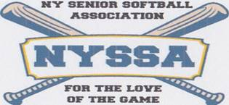

**NEW YORK SENIOR SOFTBALL ASSOCIATION**

**AUGUST 15, 2019**

**BOARD MEETING MINUTES**

**The meeting was called to order by Commissioner, Joe Ditaranto. All Board members were present.**

**The Minutes from the July 18 Board Meeting were accepted**

**The Financial Report was presented by Joe Ditaranto and accepted by the Board.**

**Bristal Assisted Living BBQ- August 21, 2019- Players may bring one guest for free.**

**Mid-Season Roster Changes- Discussions tabled for a later Board Meeting.**

**Make up dates- The Board voted to play the first two make up doubleheader dates on Wednesday August 21 and Monday August 26.**

**Team matchups and playing fields will follow the original format of the first two rainout dates earlier this season May 13 and June 10.**

**Fall All-Star Game- Monday October 7 at 7pm Allen Park.**

**Rain date Monday October 14.**

**The Fall All-Star Game is traditionally held every year on the first Monday in October.**

**Awards Luncheon- Tuesday October 22 from 11am-3pm.**

**Every manager is responsible for collecting $20 from each player attending the luncheon.**

**The league will also pay $20 for each player.**

**Managers are to hand in their luncheon collections at the September 19th meeting**

**2020 Players Application- Under review by Board Committee**

**New Business- Bob Gebel and Peter Dill announced their resignation as team managers for the 2020 season.**

**Replacement candidates will be sought from qualifying league members.**

**Beginning in 2020 each team will be issued one extra blue and one extra white shirt to be used by players arriving to play with the wrong shirt.**